# **Website Design Review - 26/06/19**

## Stage 4:

### Header:

1. Nil.

## Sign in:

1. Can you please change the email address that sends the activation link to [register@mywealthanalyst.com](mailto:register@mywealthanalyst.com). Currently its coming from my personal account.
   * Completed

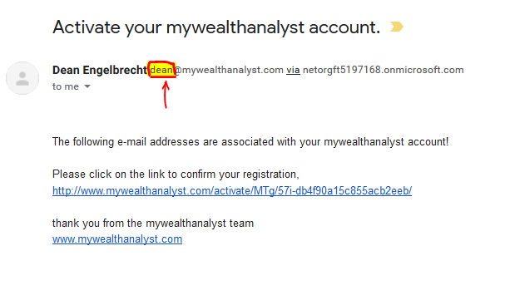

1. Also, can we use the branding fonts and colours in the welcome email including the logo and a statement about “no reply” to this email and including the contact us email for reference. See below example from coin base commerce as a guide:
   * Completed

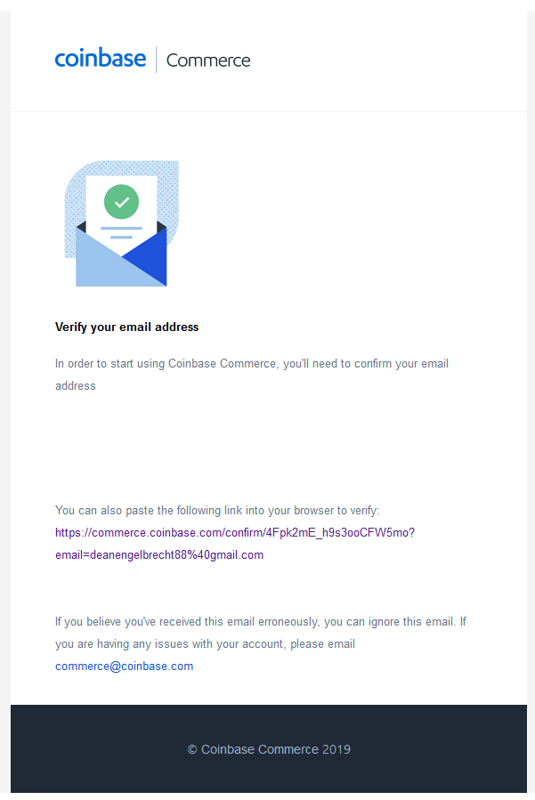

## Landing Page:

1. What’s the status of the John / Jane animation? The landing page is still a bit clunky.
   * Completed

### Live Prices:

1. Can we please display Sydney property price as default in the live prices based on the last quarterly data and include a drop down similar to the graphs so the capital city can be changed by the user, see example below:
   * Completed

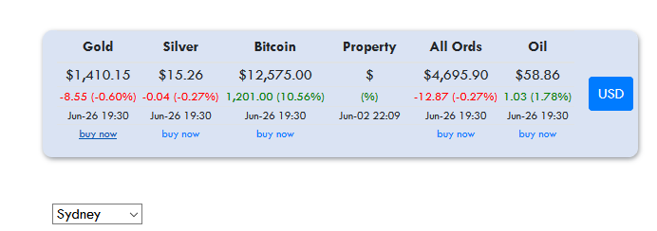

1. [To do] Affiliate links - I’ll need you to set up an account and follow the instructions to get affiliate links for the mywealthanalyst website. (for example see https://www.coinbase.com/affiliates or https://www.500affiliates.com/Help/HelpPromote.aspx)

→ note – these usually require the website to be live and for the company (e.g. 500affiliates) to ‘inspect’ the website to make sure it meets their T&Cs…

→ Once you’ve set up an affiliate account, get a ‘referral link’, this link will have your unique ID so their website knows that the referral came from you (For instance: www.plus500.com/Home.aspx?id=123456, where your account id is 123456).

### Charts:

### General:

1. Can you please ensure that whenever the ratio for House price to gold is displayed it utilizes the correct units e.g. $800,000 (House) / $1,200 (Gold) = 666 (Ratio)
   * Completed
2. Default all graph timelines to ‘All’
   * Completed

### Graph 1 – Median House Price : Gold / All Ords : Gold / All Ords PE Ratio

1. Please amend the graph 1 title to match the above highlighted in green
   * Completed
2. Assign the Median House Price:Gold ratio to the secondary axis on the left.
   * Completed

### Graph 3 – Median House Price : Gold

1. Can you please include the Switch to Property and Switch to Gold lines on the chart via standard deviation +/-1 calculation. This link explains the concept well 🡪 <https://www.mathsisfun.com/data/standard-deviation.html>
   * Completed
2. Can you please confirm that this will seek an update from the ABS data on the 1st of July?
   * Confirmed. Updater ran successfully at midnight on 1 July. No new data existed.

### Graph 4 – Median House Price : Average Annual Income

1. Can you please ensure the calculation is as follows: $800,000 (House price) / Weekly wage 1,000*52 (Annual Income) = 15.4
   * Completed

### Graph 5 - All Ords PE Ratio

1. It looks like for the All Ords PE Ratio data we will need to setup a data pull similar to the ABS data for housing and income i.e. 1st day of every month the program downloads the file to check for updates <https://www.marketindex.com.au/data-downloads>
   * Completed

### Backend:

1. Can I have access to the database on the backend of the website?
   * Login details
     + Username: [admin@admin.com](mailto:admin@admin.com)
     + Password: admin

### Advertising:

1. What’s the status on the advertising?
   * I tried doing this myself with a test account – but Google’s quality control is pretty tight, so I think it best if you do this directly using your Google account.
   * You will need to log into your Google Adsense account and add ‘www.mywealthanalyst.com’ to your account. Google will review that the site meets their T&Cs (takes about a day).
   * Once approved, Google will provide some code snippets to place in the webpage. I’ll need those snippets.
2. When the website is viewed on a mobile device the adds will have to be presented vertically between graphs.
   * Confirmed.